

BI FORECASTING INOCULATION - PREDICTING THE LIKELIHOOD OF H1N1 AND SEASONAL FLU VACCINE UPTAKE

By

Mercy Kariuki

In partial fulfillment to the requirements of Big Data and Intelligence

CIS4008-N-BF1-2023

MASTERS IN APPLIED DATA SCIENCE

September 2023

Submitted by

January 10, 2024

Copyright 2023 Mercy Kariuki

TABLE OF CONTENTS

LIST OF FIGURES 4

chapter one: Executive Summary 7

chapter two: literature review 8

chapter three: introduction 10

3.1 About this Dataset 10

3.2 Rationale 10

3.3 Objectives 11

3.4 Stakeholders 12

3.5 Data source 14

chapter four: data transform 15

4.1 Load the data 15

4.2 Data Preprocessing 19

chapter Five: KEY FINDINGS 32

5.1 VACCINATION ANALYSIS 32

5.1.1 What is the percentage of respondents who took both the H1N1 and Seasonal Vaccine, considering the overall vaccination rate? 32

5.1.2 How does H1N1 vaccinations rate differ between males and females who are health workers? 33

5.1.3 What is the percentage of respondents who took the H1N1 vs Seasonal Vaccine and have children under 6 months? 35

5.1.4 Does having a higher education contribute to the probability of receiving a vaccine? 36

5.1.5 What is the percentage of respondents who took the H1N1 vs Seasonal Vaccine depending on the Metropolitan Statistical Areas? 38

5.1.6 How many respondents with chronic medical conditions received the H1N1 and Seasonal Vaccine? 39

5.2 DEMOGRAPHIC ANALYSIS 40

5.2.1 What are the total number of respondents? 40

5.2.2 What is the distribution of respondents across different age groups? 41

5.2.3 What is the count of respondents belonging to each of the identified racial categories? 42

5.2.4 Does gender play a role in influencing the likelihood of vaccine acceptance among respondents? 42

5.2.5 How is the distribution of respondents among different marital statuses? 44

5.2.6 How is the distribution of respondents among different marital statuses? 44

5.2.7 How is the distribution of respondents among different income levels? 45

5.2.8 What is the distribution of respondents among different employment status? 46

5.2.9 What is the distribution of respondents in different households? 47

5.3 GEOGRAPHICAL ANALYSIS 48

5.3.1 What is the distribution of respondents in different Metropolitan Areas? 48

5.3.2 What is the distribution of the respondents across different MSA for each age group, considering the percentage of H1N1 vaccine uptake vs Seasonal Vaccine Uptake? 49

5.3.3 How does the percentage of respondents with chronic medical conditions vary across different MSA? 51

5.3.4 What are the income levels of the respondents in each Metropolitan Statistical Areas? 52

5.3.5 What are the levels of knowledge and concern among the Metropolitan Statistical Areas? 53

5.3.6 What is the distribution of the respondents across different MSA for each employment status? 55

CONCLUSION 56

RECOMMENDATIONS 56

REFERENCES 57

APPENDIX 59

Data Pre-Processing 59

Cleaning Process 61

DAX and M Language 71

Dashboard 86

SELF ASSESSMENT 98

## LIST OF FIGURES

Fig 1. Vaccinations distribution by race 7

Fig 2. H1N1 and Seasonal Flu Vaccines Overview 8

Fig 3. H1N1 and Seasonal Flu dataset description – Part 1 15

Fig 4. H1N1 and Seasonal Flu dataset description – Part 2 15

Fig 5. Get data - powerbi 16

Fig 6. Choose dataset format- powerbi 18

Fig 7. Locate and select your dataset - powerbi 18

Fig 8 Transform Data - powerbi 19

Fig 9. Transform data - powerbi 19

Fig 10. Duplicate table- powerbi 20

Fig 11. Remove errors- powerbi 20

Fig 12. Remove Errors – M Language - powerbi 22

Fig 13. Duplicated table- powerbi 22

Fig 14. Star Schema- powerbi 23

Fig 15. Fact table- powerbi 24

Fig 16. Manage Relationships- powerbi 24

Fig 17. Create H1N1 Concern and Knowledge Dimension- powerbi 26

Fig 18. Remove Unnecessary columns- powerbi 27

Fig 19. Create Behavior Information Dimension - powerbi 27

Fig 20. M Language for creating Behavioral Information Dimension- powerbi 27

Fig 21. Created dimensions - powerbi 28

Fig 22. Close and Apply your changes - powerbi 28

Fig 23. Loading your changes - powerbi 29

Fig 24. Uploaded data to powerbi 29

Fig 25. DAX formulas - powerbi 32

Fig 26. Vaccination Rates 32

Fig 27. Number of respondents who received the Seasonal Vaccine as well as the H1N1 vaccine 32

Fig 28. Filter used to see who received the H1N1 Vaccine 32

Fig 29. Number of respondents who received the H1N1 Vaccine as well as the Seasonal Vaccine 33

Fig 30. Filter used to see who received the Seasonal Vaccine 33

Fig 31. Percentage of respondents that are health workers who received the H1N1 and Seasonal Vaccine 34

Fig 32. Percentage of respondents that received the H1N1 and Seasonal Vaccine according to Gender 34

Fig 33. Percentage of respondents with children under 6 months that received the H1N1 and Seasonal Vaccine 35

Fig 34. Number of respondents that received the H1N1 and Seasonal Vaccine according to education levels 36

Fig 35. Percentage of respondents that received the H1N1 and Seasonal Vaccine according to MSA 38

Fig 36. Respondents with Chronic Medical Conditions that received the H1N1 and Seasonal Vaccine 39

Fig 37. Total Number of Respondents 40

Fig 38. Age Distribution of the rrespondents 41

Fig 39. Racial Distribution of the respondents 42

Fig 40. Gender Distribution of the respondents 42

Fig 41. Marital Status of the respondents 44

Fig 42. Education Status of the respondents 45

Fig 43. Income Distribution of the respondents 45

Fig 44. Employment Status of the respondents 46

Fig 45. Household persons of the respondents – Part 1 47

Fig 46. Household persons of the respondents – Part 2 48

Fig 47. Distribution of respondents across different msas 49

Fig 48 H1N1 and Seasonal vaccine uptake rate of respondents across different msas for each age group 50

Fig 49. Percentage of respondents with chronic medical conditions across different msas 51

Fig 50. Income levels of respondents across different msas 52

Fig 51. Levels of Knowledge and concern of respondents across different msas – Part 1 53

Fig 52. Levels of Knowledge and concern of respondents across different msas – Part 2 54

Fig 53. Levels of Knowledge and concern of respondents across different msas – Part 3 54

Fig 54. Employment Status of respondents across different msas 55

Fig 55. Dataset in Excel 60

Fig 56. Get Data into powerbi 60

Fig 57. Create Dimensions 61

Fig 58. Illustration of cleaning process in powerbi of the main dataset 62

Fig 59. Illustration of cleaning process in powerbi of ‘Behavioral Information’ dimension 62

Fig 60. Illustration of cleaning process in powerbi of ‘Doctor’s Recommendation’ dimension 63

Fig 61. Illustration of cleaning process in powerbi of ‘Knowledge/Concern’ dimension 64

Fig 62. Illustration of cleaning process in powerbi of ‘Chronic Level’ dimension 65

Fig 63. Illustration of cleaning process in powerbi of ‘Opinion’ dimension 65

Fig 64. Illustration of cleaning process in powerbi of ‘Received Vaccine’ dimension 66

Fig 65. Illustration of cleaning process in powerbi of ‘Household Persons’ dimension 66

Fig 66. Illustration of cleaning process in powerbi of ‘Census MSA’ dimension 67

Fig 67. Illustration of cleaning process in powerbi of ‘Employment Status’ dimension 67

Fig 68. Illustration of cleaning process in powerbi of ‘Health Worker’ dimension 68

Fig 69. Illustration of cleaning process in powerbi of ‘Health Insurance’ dimension 68

Fig 70. Illustration of cleaning process in powerbi of ‘Personal Information’ dimension 69

Fig 71. Illustration of cleaning process in powerbi of ‘Income Level’ dimension 69

Fig 72. Illustration of cleaning process in powerbi of ‘Rent or Own’ dimension 70

Fig 73. Illustration of cleaning process in powerbi of ‘Child Under 6 months’ dimension 70

Fig 74. M Language illustration of cleaning process in powerbi of the main dataset 71

Fig 75. M Language illustration of cleaning process in powerbi of the ‘Behavioral Information’ dimension 72

Fig 76. M Language illustration of cleaning process in powerbi of the ‘Doctor’s Recommendation’ dimension 73

Fig 77. M Language illustration of cleaning process in powerbi of the ‘Knowledge/Concern’ dimension 74

Fig 78. M Language illustration of cleaning process in powerbi of the ‘Chronic Level’ dimension 75

Fig 79. M Language illustration of cleaning process in powerbi of the ‘Opinion’ dimension 76

Fig 80. M Language illustration of cleaning process in powerbi of the ‘Received Vaccine’ dimension 77

Fig 81. M Language illustration of cleaning process in powerbi of the ‘Household Persons’ dimension 78

Fig 82. M Language illustration of cleaning process in powerbi of the ‘Census MSA’ dimension 79

Fig 83. M Language illustration of cleaning process in powerbi of the ‘Employment Status’ dimension 80

Fig 84. M Language illustration of cleaning process in powerbi of the ‘Health Worker’ dimension 81

Fig 85. M Language illustration of cleaning process in powerbi of the ‘Health Insurance’ dimension 82

Fig 86. M Language illustration of cleaning process in powerbi of the ‘Personal Information’ dimension 83

Fig 87. M Language illustration of cleaning process in powerbi of the ‘Income Level’ dimension 84

Fig 88. M Language illustration of cleaning process in powerbi of the ‘Rent or Own’ dimension 85

Fig 89. M Language illustration of cleaning process in powerbi of the ‘Child Under 6 months’ dimension 86

Fig 90. Dashboard 87

Fig 91. Dashboard – Vaccination Rates 88

Fig 92. Dashboard – Overall Vaccination Rate DAX formula 88

Fig 93. Dashboard – H1N1 Vaccination Rate DAX formula 88

Fig 94. Dashboard – Seasonal Vaccination Rate DAX formula 89

Fig 95. Dashboard – Public Concern and Knowledge 89

Fig 96. Dashboard – Average Knowledge about H1N1 DAX formula 89

Fig 97. Dashboard – Average Concern about H1N1 DAX formula 89

Fig 98. Dashboard – Doctor’s Recommendations 90

Fig 99. Dashboard Doctor’s Recommendations for Seasonal Vaccine DAX formula 90

Fig 100. Dashboard Doctor’s Recommendations for H1N1 Vaccine DAX formula 90

Fig 101. Dashboard – Household Persons 90

Fig 102. Dashboard Average No. Of Adults in a Household DAX formula 90

Fig 103. Dashboard Average No. Of Children in a Household DAX formula 91

Fig 104. Dashboard – Health Workers and Insurance 91

Fig 105. Dashboard Total Number of Health Workers DAX formula 91

Fig 106. Dashboard Percentage Number of respondents with Health Insurance DAX formula 92

Fig 107. Dashboard – Rent Payers and Home owners 92

Fig 108. Dashboard Percentage Number of Rent payers DAX formula 92

Fig 109. Dashboard Percentage Number of Home owners DAX formula 93

Fig 110. Dashboard – Age Distribution of the respondents 93

Fig 111. Dashboard Personal Information Table/Dimension 94

Fig 112. Dashboard – Employment Status and Income Level 94

Fig 113. Dashboard Employment Status Table/Dimension 94

Fig 114. Dashboard Income Level Table/Dimension 95

Fig 115. Dashboard – Respondents with children under 6 months 95

Fig 116. Dashboard Percentage of Respondents with children under 6 months DAX formula 96

Fig 117. Dashboard – Number of people who believe in the Effectiveness of H1N1 and Seasonal Vaccine 96

Fig 118. Dashboard Opinion Table/Dimension 97

Fig 119. Dashboard Opinion Table/Dimension 97

## **chapter** one: Executive Summary

The H1N1 influenza virus, also known as the "swine flu," started a pandemic in the spring of 2009 and spread throughout the entire world. According to research, it resulted in more than 200,000 hospitalizations and 24,000 deaths on average (Groshkopf et al., 2013). One effective way to stop the influenza virus from spreading is to get vaccinated against seasonal influenza. Vaccination coverage gaps persist in spite of this recognition; racial/ethnic minority groups are less likely than White, non-White groups to have received the adult US influenza vaccination, as are populations at high risk of influenza related.

For example, influenza vaccination coverage for the Hispanic is 4.85% percentage-points that the Black who are also 3.30% less than Other/Multiple ethic group. This translates to the White ethnic group having 4.51 higher odds of receiving an influenza vaccine than the non-white.

##### Fig 1. Vaccinations distribution by race

Some of the key findings that we will be looking at include:

* Vaccination Analysis
* Demographic Analysis
* Geographical Analysis
* H1N1 & Seasonal Opinion Analysis
* Behavior Analysis by:
  + Bought a face mask
  + Frequently washed their hands or used a sanitizer
  + Reduced time at large gatherings
  + Has taken antiviral medications
  + Avoided close contact with people with flu-like symptoms
  + Reduced contact with people outside of their own household
  + Avoided touching eyes, nose or mouth

For the image to your left, we can see the overview analysis of the H1N1 and Seasonal Vaccines. A key point to note of the average level or knowledge and concern on H1N1 at 1.26 and 1.61 respectively, having 2 as a lot of knowledge and 0 representing no knowledge while on the other hand we have 3 – very concerned and 0 – not concerned at all

##### Fig 2. H1N1 and Seasonal Flu Vaccines Overview

## chapter two: literature review

The provided data includes information on individuals' level of concern about H1N1, their knowledge about H1N1, their behaviors related to antiviral medications, avoidance Behaviors related to antiviral medications, avoidance of exposure, face mask usage, hand hygiene, and large gatherings. These findings are important for understanding the factors that influence individuals' attitudes and behaviors towards H1N1 and seasonal flu vaccines (d'Alessandro et al., 2012).

The data suggests that there are several factors influencing individuals' attitudes and behaviors towards H1N1 and seasonal flu vaccines. One important factor is the association between seasonal influenza vaccination and intentions to get the H1N1 vaccine (Kelly et al., 2021).

This indicates that individuals who are more likely to get vaccinated for seasonal flu are also more likely to have intentions of getting the H1N1 vaccine (Frank, 2015). Additionally, attitudes, subjective norms, perceived benefits, and perceived barriers were found to predict intentions to get the H1N1 vaccine.

These findings highlight the importance of addressing common attitudinal barriers and concerns about vaccine safety in order to increase vaccine uptake for both H1N1 and seasonal flu vaccines. The findings from the data suggest that individuals' level of concern and knowledge about H1N1, as well as their behaviors related to antiviral medications and avoidance, can play a significant role in their decision to get vaccinated for H1N1 and seasonal flu. Furthermore, the data suggests that positive subjective norms have a significant influence on H1N1 vaccine uptake (Guidry et al., 2018).

It is important to note that negative attitudes towards the vaccines, such as concerns about safety, can also impact vaccine uptake. These findings are consistent with previous research on seasonal flu vaccine uptake, which has shown that negative attitudes towards the vaccine are associated with lower uptake rates. Overall, the data highlights the importance of addressing attitudes, subjective norms, perceived benefits, and perceived barriers in promoting vaccine uptake for H1N1 and seasonal flu (Frank, 2015). In summary, the data suggests that individuals' level of concern and knowledge about H1N1, as well as their behaviors related to antiviral medications, avoidance of exposure, face mask usage, hand hygiene, and large gatherings, are significant factors influencing their attitudes and behaviors towards H1N1 and seasonal flu vaccines. In order to increase vaccine uptake for H1N1 and seasonal flu, it is important for healthcare professionals, employers, unions, teachers' associations, health insurers, and school boards to address these factors by providing accurate information about vaccine safety, addressing concerns, and promoting the benefits of vaccination. In conclusion, addressing attitudes, subjective norms, perceived benefits, and perceived barriers is crucial in promoting vaccine uptake for both H1N1 and seasonal flu vaccines.

## chapter three: introduction

## 3.1 About this Dataset

In this dataset, we take a look at vaccinations, an important public health measure to combat infectious diseases. Vaccines provide immunization for individuals, and immunizations in a community can further reduce the spread of disease through “heard community”. Starting the spring of 2009, a pandemic caused by the H1N1 influenza virus, colloquially known as “swine flu”, spread across the world. Researchers estimate it was responsible for 151,000 to 575,000 deaths worldwide within the first year. A vaccine against the H1N1 flu virus became publicly available in October 2009. In late 2009 and early 2010, the United States conducted the National 2009 H1N1 Influenza Survey. This survey asked respondents whether they had received the H1N1 and Seasonal Flu vaccinations, as well as questions about themselves. These additional questions covered their social, economic and demographic backgrounds, opinions about disease risks and vaccine effectiveness, and behaviors to reduce transmission. A better understanding of how these characteristics relate to personal vaccination patterns can guide future public health efforts.

## 3.2 Rationale

The rationale behind selecting this ICA resides in its explicit objective to underscore the pivotal role of business Intelligence in the healthcare domain. The intended audience for the presentation comprises of stakeholders from [Croydon GP Collaborative](https://www.cgpc.uk/) and the participants at the BI Exhibition for [TU PowerBI for Women by Women](https://community.fabric.microsoft.com/t5/Teesside-University-PowerBI-by/gh-p/TeessideUniversityPowerBIbyWomenforWomen). The primary aim is to elucidate the adept application of data analysis and visualization methodologies, thereby furnishing valuable insights and substantiating informed decisions within the healthcare sector.

This initiative further distinguishes itself by the incorporation of state-of-the-art technologies, reflecting a concerted effort to address exigent healthcare challenges. The strategic integration of Power BI, a leading BI tool, underscores a commitment to harnessing advanced analytical techniques for decision-making processes.

In consonance with the objectives of Industry 4.0, this project represents a forward-looking endeavor, leveraging innovative technologies to tackle contemporary healthcare issues. The bifocal engagement with key stakeholders and a specialized exhibition tailored for women in technology imparts an inclusive dimension, contributing to a broader narrative of empowerment and representation within the domain of data and business intelligence.

## 3.3 Objectives

To examine the determinants that impact the proclivity of individuals to receive vaccinations for both H1N1 and seasonal influenza. This inquiry encompasses a comprehensive analysis of factors across demographic, socio-economic, psychological, and contextual dimensions.

1. Demographic Variables:

* Age: Variations in vaccine uptake within distinct age cohorts, with differential inclinations evident among the elderly and young children.
* Gender: Discerning potential gender-based differentials in vaccination rates, reflective of disparate health-seeking behaviors.

1. Socio-economic Parameters:

* Income: Exploration of the economic dimension, wherein individuals of lower income strata may encounter impediments related to affordability and accessibility.
* Education: Scrutiny of education levels as a determinant, considering the correlation between education and health literacy.

1. Health-related Beliefs and Attitudes:

* Perceived Susceptibility: Examination of individuals' perceptions concerning their susceptibility to influenza, shaping vaccination decisions.
* Attitudes Towards Vaccination: Analysis of prevailing beliefs and attitudes surrounding vaccine efficacy and safety, exerting substantial influence on vaccination behavior.

1. Access to Healthcare Facilities:

* Geographical Proximity: Assessment of the impact of geographical accessibility to vaccination centers and healthcare facilities.
* Healthcare System Variables: Evaluation of healthcare system efficiency and accessibility as critical determinants of vaccination uptake.

1. Cultural and Social Constructs:

* Cultural Beliefs: Investigation into the role of cultural norms and beliefs regarding health and preventive measures in shaping vaccination decisions.
* Social Networks: Examination of the influence of peer dynamics and social networks on vaccine acceptance or hesitancy.

1. Public Health Initiatives:

* Government-led Campaigns: Analysis of the efficacy of public health campaigns and interventions in shaping perceptions and behaviors related to vaccination.
* Policy Implementation: Evaluation of the impact of mandatory vaccination policies on overall vaccine coverage.

1. Vaccination History:

* Previous Vaccination Behavior: Examination of the influence of past vaccination behaviors on current compliance and proclivity.

## 3.4 Stakeholders

The stakeholders associated with the dataset on vaccination patterns play pivotal roles in the interpretation, utilization, and dissemination of insights derived from the dataset. The identified stakeholders are delineated as follows:

1. Policy Makers:

* *Role*: Informed decision-making regarding public health regulations.
* *Utilization*: Guidance for vaccine mandates, optimization of distribution strategies, and initiation of awareness-enhancing initiatives.

1. Vaccine Manufacturers:

* *Role*: Strategic decision-making for market forecasting, distribution tactics, and production planning.
* *Utilization*: Understanding vaccination trends to inform production and distribution strategies.

1. Medical Professionals:

* *Role*: Healthcare practitioners, physicians, nurses, and stakeholders in patient care.
* *Utilization*: Gaining insights into vaccination patterns and factors influencing patient choices to enhance communication tactics and patient education initiatives.

1. Public Health Agencies:

* *Role*: Focused on enhancing public health outcomes.
* *Utilization*: Allocation of resources, implementation of intervention tactics, and execution of immunization initiatives based on dataset information.

1. Researchers and Academia:

* *Role*: Advancement of scientific comprehension, particularly for epidemiologists and public health researchers.
* *Utilization*: Providing a foundation for further investigation and research on vaccination practices and effectiveness.

1. Educational Institutions:

* *Role*: Inclusive of schools, colleges, and universities.
* *Utilization*: Influencing health and safety policies based on vaccination trends across various age groups.

1. General Public:

* *Role*: Indirect beneficiaries of dataset dissemination.
* *Utilization*: Augmented public confidence and knowledge of vaccination recommendations, contributing to informed health-related decision-making.

## 3.5 Data source

This dataset is derived from [Kaggle](https://www.kaggle.com/datasets/arashnic/flu-data), a preeminent platform within the domain of data science that serves as a collaborative space for practitioners and enthusiasts alike. Kaggle offers a repository of datasets which facilitates participation in competitive events that span various facets of data analysis, machine learning and predictive modelling. Moreover, Kaggle generates a global community, fostering collaborative engagement and knowledge exchange among data science professionals. The platform’s structure encourages continual learning, skill demonstration, and the potential for recognition through participation in competitions, which may yield valuable rewards.

Our dataset contains 26,707 rows and 36 features which. Fig 3 Part 1 and 2 will provide a comprehensive description of our dataset.

##### Fig 3. H1N1 and Seasonal Flu dataset description – Part 1

##### Fig 4. H1N1 and Seasonal Flu dataset description – Part 2

## chapter four: data transform

## 4.1 Load the data

Open PowerBI and select Get Data

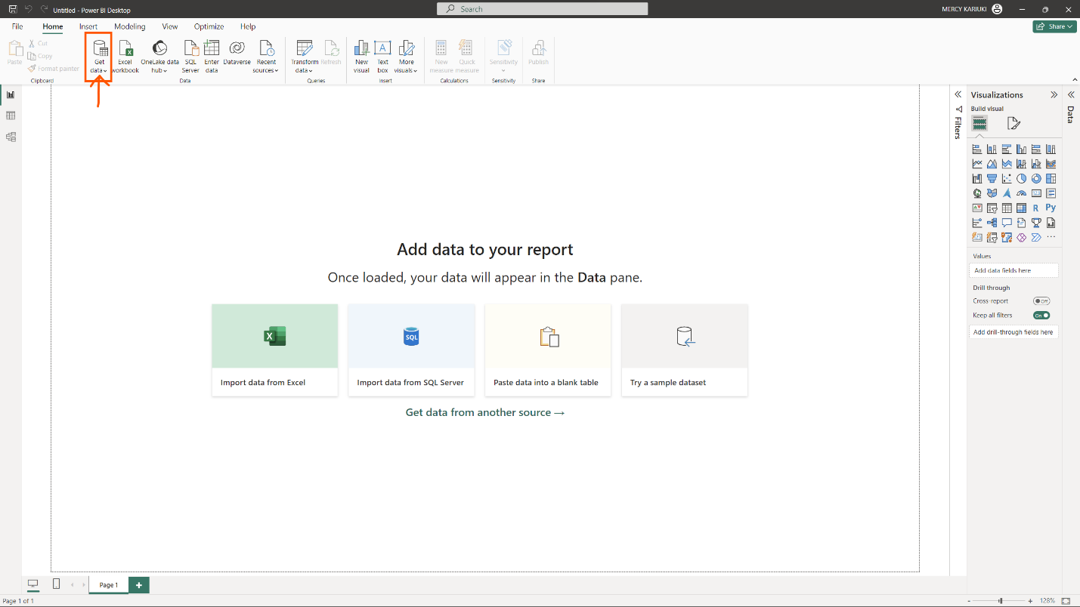

##### Fig 5. Get data - PowerBI

Select the source of your dataset depending on the format of your dataset. For this project, out dataset in in CSV and therefore, we will be selecting “Text/CSV”

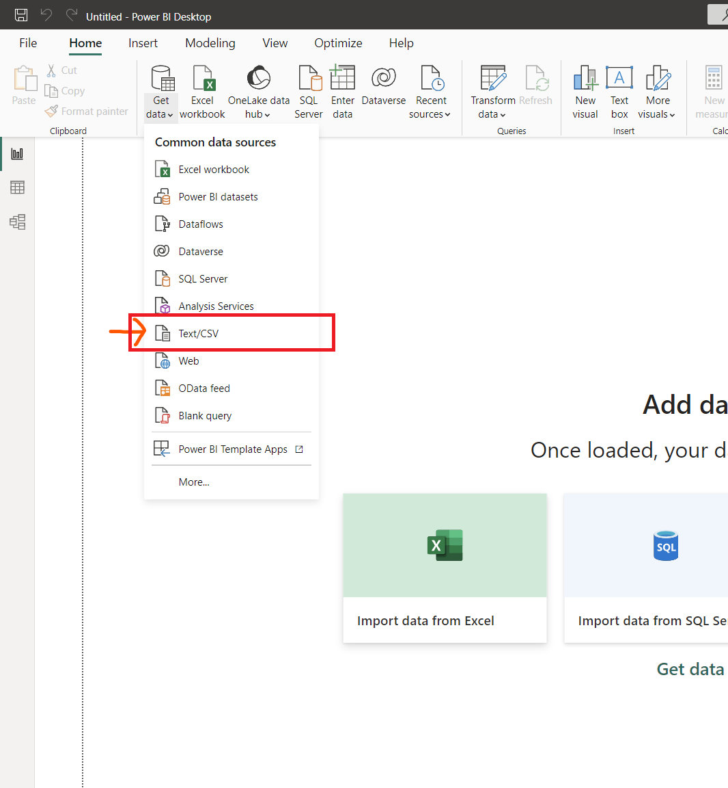

##### Fig 6. Choose dataset format- PowerBI

This will then direct you to your folders on your local devices where you will navigate to where your dataset is stored. In this scenario, our dataset is “H1N1_flu_vaccines-Clean”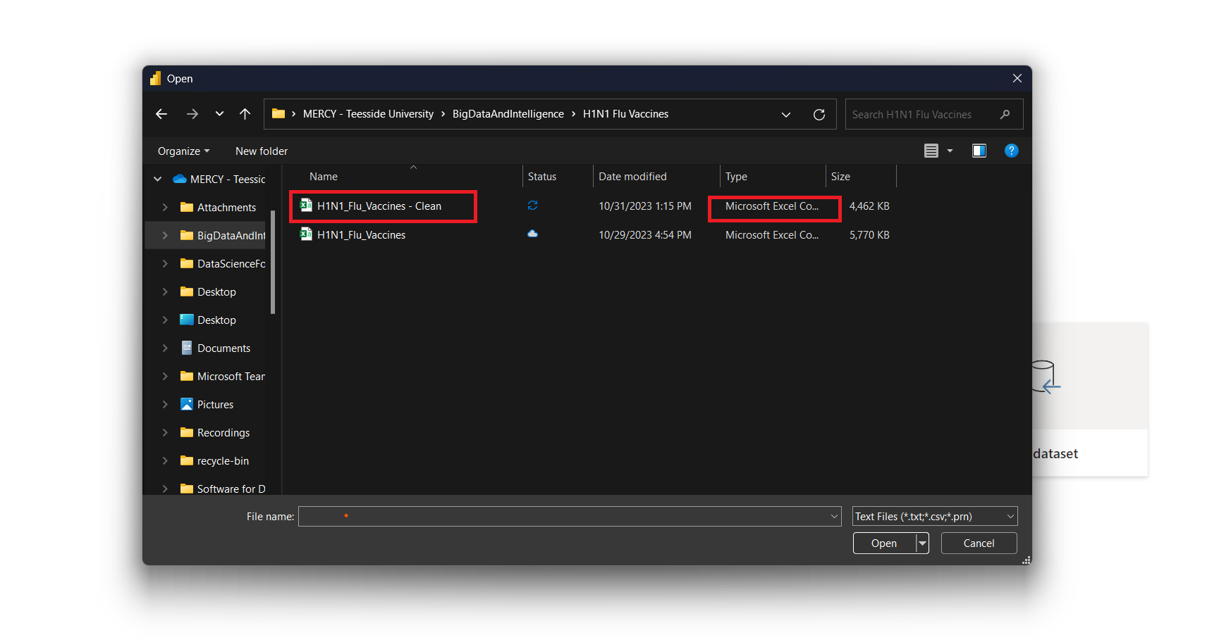

##### Fig 7. Locate and select your dataset - PowerBI

Once you’ve selected your dataset and clicked on “Open”, you will be presented with three options: Load, Transform or Cancel.

Click on Transform.

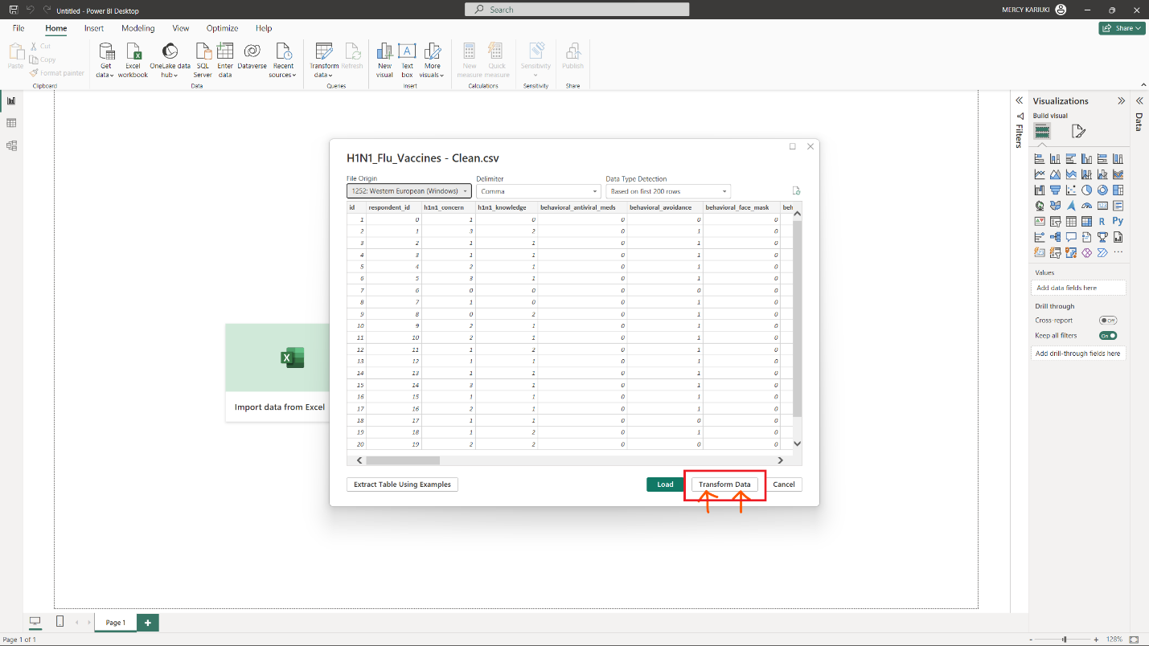

##### Fig 8 Transform Data - PowerBI

##### Fig 9. Transform data - PowerBI

## 4.2 Data Preprocessing

Right-click on your dataset in the Queries Panel and duplicate our dataset. Alternatively, you can click Ctrl+C then Ctrl+V to Copy and Paste your data.

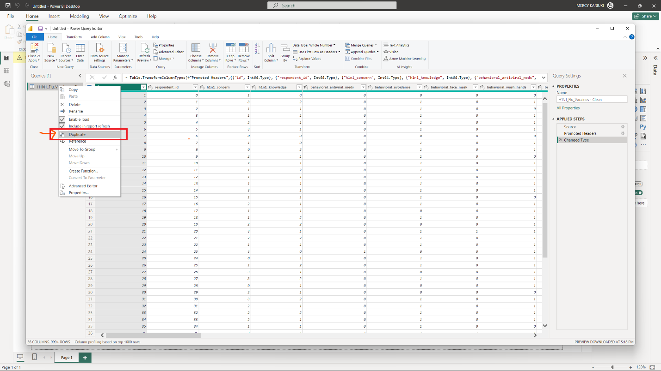

##### Fig 10. Duplicate table- PowerBI

Remove any errors in your data which includes null values.

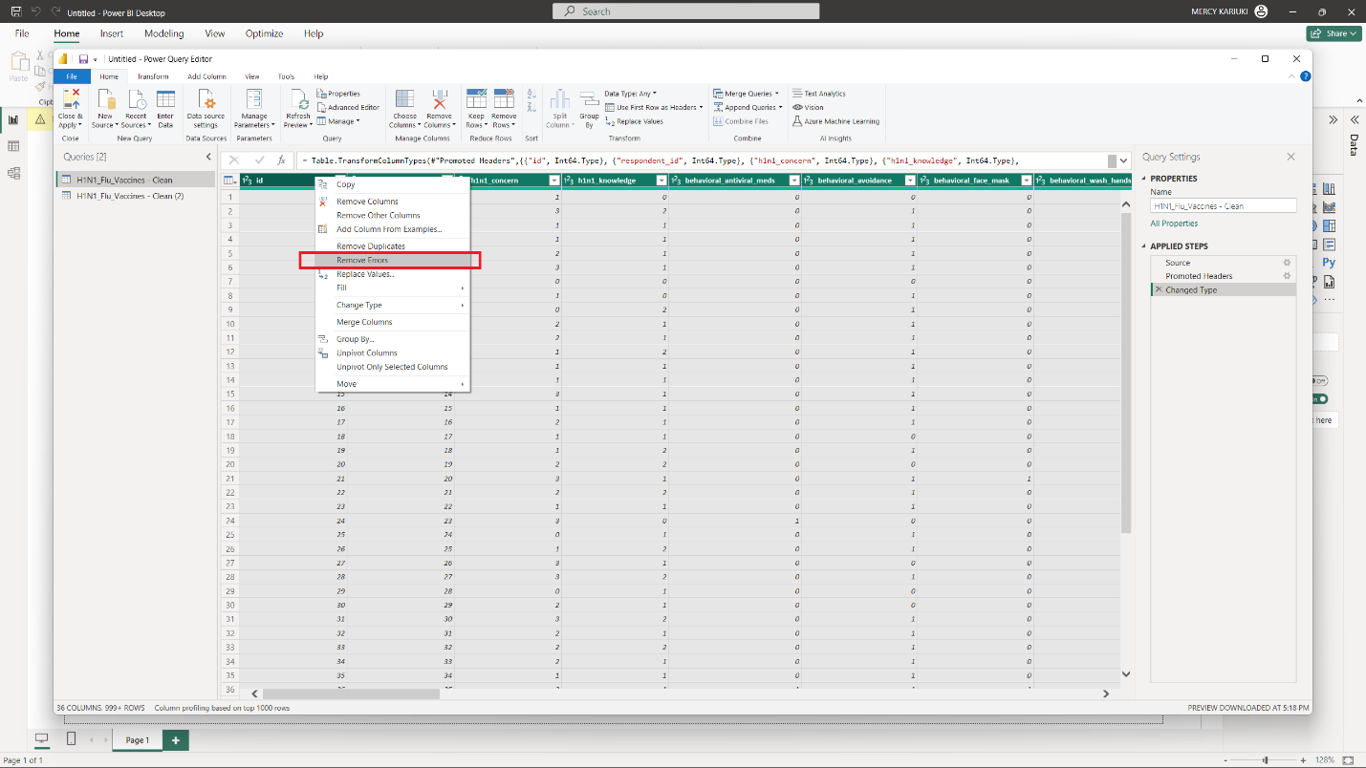

##### Fig 11. Remove errors- PowerBI

M Language to remove Errors

#"Removed Errors" = Table.RemoveRowsWithErrors(#"Changed Type", {"id", "respondent_id", "h1n1_concern", "h1n1_knowledge", "behavioral_antiviral_meds", "behavioral_avoidance", "behavioral_face_mask", "behavioral_wash_hands", "behavioral_large_gatherings", "behavioral_outside_home", "behavioral_touch_face", "doctor_recc_h1n1", "doctor_recc_seasonal", "chronic_med_condition", "child_under_6_months", "health_worker", "health_insurance", "opinion_h1n1_vacc_effective", "opinion_h1n1_risk", "opinion_h1n1_sick_from_vacc", "opinion_seas_vacc_effective", "opinion_seas_risk", "opinion_seas_sick_from_vacc", "age_group", "education", "race", "sex", "income_poverty", "marital_status", "rent_or_own", "employment_status", "census_msa", "household_adults", "household_children", "h1n1_vaccine", "seasonal_vaccine"})



##### Fig 12. Remove Errors – M Language - PowerBI

##### Fig 13. Duplicated table- PowerBI

The purpose of duplicating our original dataset is for us to create a star schema. A **Star Schema** refers to a data modeling technique commonly employed in relational databases for organizing and structuring data for efficient querying and analysis. It is characterized by a central “fact” table connected to multiple “dimension” tables in a star-like configuration.

##### Fig 14. Star Schema- PowerBI

**Fact Table**: The central component of a star schema. The fact table contains qualitative data or measured, often numerical values that represent the business metrics or Key Performance Indicators (KPIs) under analysis.

##### Fig 15. Fact table- PowerBI

##### Fig 16. Manage Relationships- PowerBI

**Dimension Table:** Surrounding the fact table are the dimension tables, each representing a categorical attributor descriptor related to the data in the fact table. These attributes could include but are not limited to information such as time, geography, product details or customer details.

**Relationships:** The relationships between fact table and dimension tables are established through primary and key connections. These relationships form the structure of the start schema, facilitating data retrieval and analysis.

***Create H1N1 Concern and Knowledge Dimension***

##### Fig 17. Create H1N1 Concern and Knowledge Dimension- PowerBI

##### Fig 18. Remove Unnecessary columns- PowerBI

##### Fig 19. Create Behavior Information Dimension - PowerBI

##### Fig 20. M Language for creating Behavioral Information Dimension- PowerBI

This will be applied to the other columns to create the star schema.

##### Fig 21. Created dimensions - PowerBI

##### Fig 22. Close and Apply your changes - PowerBI

##### Fig 23. Loading your changes - PowerBI

##### Fig 24. Uploaded data to PowerBI

We will create a Measurement table to store a range of DAX (Data Analysis Expressions) queries to derive calculation for our data visualization.

##### Fig 25. DAX formulas - PowerBI

## chapter Five: KEY FINDINGS

## 5.1 VACCINATION ANALYSIS

### 5.1.1 What is the percentage of respondents who took both the H1N1 and Seasonal Vaccine, considering the overall vaccination rate?

##### Fig 26. Vaccination Rates

##### Fig 27. Number of respondents who received the Seasonal Vaccine as well as the H1N1 vaccine

##### Fig 28. Filter used to see who received the H1N1 Vaccine

Half of the surveyed participants, accounting for 50.22%, underwent vaccination. Among these individuals, 21% received the H1N1 vaccine, while 46% were administered the Seasonal vaccine. Notably, within the subset of respondents who received the Seasonal vaccine (46.56%), a significant proportion, specifically 82.78%, concurrently received the H1N1 vaccine. It is imperative to highlight that this outcome was discerned through the application of a bespoke filter incorporated into our analytical methodology.

##### Fig 29. Number of respondents who received the H1N1 Vaccine as well as the Seasonal Vaccine

##### Fig 30. Filter used to see who received the Seasonal Vaccine

Furthermore, it is observed that a proportion of 37.77% among the respondents received both the Seasonal vaccine and the H1N1 vaccine concurrently.

### 5.1.2 How does H1N1 vaccinations rate differ between males and females who are health workers?

This visual was created using a gauge, a visual representation designed to succinctly convey a singular data point in relation to pre-established benchmarks or targets. The value is the central data point or quantitative measure that the gauge encapsulates, denoting a numerical value or percentage.

##### Fig 31. Percentage of respondents that are health workers who received the H1N1 and Seasonal Vaccine

##### Fig 32. Percentage of respondents that received the H1N1 and Seasonal Vaccine according to Gender

We can discern that 10.85% of the survey participants identify as health workers, with 13.64% being female and 6.78% being male. Among the health workers, 40.95% received the H1N1 vaccine, and 64.71% received the Seasonal vaccine.

Within the cohort of individuals who received the H1N1 vaccine, it is discerned that 40.95% partook in this immunization. Among females, 18.93% refrained from receiving the vaccine, while 41.01% opted for vaccination. Conversely, among males, 18.73% chose not to undergo H1N1 vaccination, while 40.76% received the vaccine.

Regarding the Seasonal Vaccine, the demographic distribution indicates that among females, 47.19% abstained from receiving the vaccine, while 65.88% underwent vaccination. In the male cohort, 40.5% chose not to receive the Seasonal Vaccine, with 61.28% electing to undergo vaccination. These figures offer a detailed insight into the gender-specific patterns of Seasonal Vaccine acceptance, underscoring the nuanced dynamics within the vaccination landscape.

### 5.1.3 What is the percentage of respondents who took the H1N1 vs Seasonal Vaccine and have children under 6 months?

##### Fig 33. Percentage of respondents with children under 6 months that received the H1N1 and Seasonal Vaccine

The examination of vaccination patterns concerning the H1N1 and Seasonal vaccines in relation to respondents with children under 6 months reveals insightful statistics. Of the total respondents, 11.49% received the H1N1 vaccine, with the majority, constituting 88.51%, not having children in this age bracket. In contrast, 11.49% of respondents reported having children under 6 months and receiving the H1N1 vaccine. Similarly, 8.4% of respondents received the Seasonal vaccine, with 92.27% indicating the absence of children under 6 months. Conversely, 8.46% of respondents reported having children in this age group while receiving the Seasonal vaccine. This detailed breakdown provides a comprehensive understanding of the vaccination choices among respondents in the context of their parental status, contributing to a nuanced interpretation of immunization behaviors.

This visual was created using a table heatmap which refers to a visual representation employed in data analysis and reporting, characterized by a tabular structure where numerical values are represented through a color gradient. Each cell within the table corresponds to a specific intersection of row and column, with the color intensity conveying the magnitude of the associated numerical value.

### 5.1.4 Does having a higher education contribute to the probability of receiving a vaccine?

##### Fig 34. Number of respondents that received the H1N1 and Seasonal Vaccine according to education levels

This chart is created using a lipstick column chart, a specific type of data visualization that combines elements of a traditional column chart with additional graphical elements, akin to a lipstick tube, to enhance the visual appeal and communicative impact.

The investigation into the vaccination patterns among respondents with varying levels of educational attainment yields discernible insights. Specifically, among respondents with an educational background of less than 12 years, 17% reported receiving the H1N1 vaccine, while 40% opted for the Seasonal Vaccine. Those with precisely 12 years of education exhibited an increase in H1N1 vaccine uptake at 18%, with a parallel increase in Seasonal Vaccine acceptance at 45%. Notably, individuals identified as college graduates displayed a higher proclivity for the H1N1 vaccine at 25%, while 31% received the Seasonal Vaccine. Respondents with some college education reported a 21% reception rate for the H1N1 vaccine and a 45% reception rate for the Seasonal vaccine. This granular breakdown facilitates a nuanced examination of vaccination behaviors in correlation with varying educational backgrounds, contributing to a comprehensive understanding of immunization preferences among respondents with higher education.

The examination of vaccination patterns in relation to varying levels of educational attainment suggests a discernible association between higher education and the probability of vaccine reception. Notably, individuals identified as college graduates exhibit an increased propensity for both the H1N1 and Seasonal vaccines, with reception rates of 25% and 31%, respectively. This trend is notable when compared to cohorts with lower educational backgrounds, where reception rates are relatively lower.

While the data implies a positive correlation between higher education and vaccine acceptance, it is essential to consider additional factors and conduct further statistical analyses to establish the strength and significance of this association. Variables such as socioeconomic status, health literacy, and access to healthcare resources may influence vaccination decisions. Therefore, a nuanced exploration, incorporating multivariate analyses and statistical testing, would provide a more comprehensive understanding of the role of higher education in shaping vaccine reception probabilities.

### 5.1.5 What is the percentage of respondents who took the H1N1 vs Seasonal Vaccine depending on the Metropolitan Statistical Areas?

##### Fig 35. Percentage of respondents that received the H1N1 and Seasonal Vaccine according to MSA

The examination of vaccination patterns among respondents based on their residence within Metropolitan Statistical Areas (MSA) reveals nuanced insights into the prevalence of H1N1 and Seasonal vaccine uptake. The data illustrates differential vaccination rates across distinct metropolitan classifications, delineated as MSA, Non-MSA, and MSA excluding the principal city.

For the H1N1 vaccine, the percentages of respondents vaccinated are as follows: 21.4% within the broader MSA category, 21.2% for Non-MSA areas, and 21.2% for MSAs excluding the principal city. These figures denote relatively consistent vaccination rates across the specified MSA classifications.

Conversely, in the context of the Seasonal vaccine, discernible variations emerge. Notably, 45.4% of respondents residing in MSAs received the Seasonal vaccine, while 45.8% of those in Non-MSA areas opted for vaccination. Intriguingly, a higher percentage of 47.8% is observed for respondents within MSAs excluding the principal city.

This differential in Seasonal vaccine uptake may be attributed to various factors, including healthcare accessibility, awareness campaigns, and population density variations between MSA classifications. Such nuanced analyses contribute to a comprehensive understanding of vaccination behaviors within specific geographical contexts, aiding public health strategists in tailoring interventions to address regional disparities effectively. Further exploration and multivariate analyses are warranted to unveil the intricate determinants influencing vaccine acceptance within diverse Metropolitan Statistical Areas.

### 5.1.6 How many respondents with chronic medical conditions received the H1N1 and Seasonal Vaccine?

##### Fig 36. Respondents with Chronic Medical Conditions that received the H1N1 and Seasonal Vaccine

The analysis of vaccination patterns among respondents based on the presence or absence of chronic medical conditions yields insightful statistics. The data indicates the following distribution of respondents receiving the H1N1 and Seasonal vaccines:

For the H1N1 Vaccine:

* Respondents with a chronic medical condition: 27.5% of 3666 individuals received the H1N1 vaccine.
* Respondents without a chronic medical condition: 18.9% of 2008 individuals received the H1N1 vaccine.

For the Seasonal Vaccine:

* Respondents with a chronic medical condition: 60.4% of 8035 individuals received the Seasonal vaccine.
* Respondents without a chronic medical condition: 41.4% of 4400 individuals received the Seasonal vaccine.

The presence of chronic medical conditions appears to exert a discernible influence on the frequency of receiving both the H1N1 and Seasonal Vaccines, as evidenced by the provided data.

For the H1N1 Vaccine, the percentage of respondents with chronic medical conditions who received the vaccine is notably higher at 27.5%, in contrast to the percentage among those without chronic medical conditions, which stands at 18.9%. This discrepancy suggests that individuals with chronic medical conditions exhibit a heightened propensity for receiving the H1N1 Vaccine.

Similarly, in the context of the Seasonal Vaccine, respondents with chronic medical conditions display a substantially elevated rate of vaccination at 60.4%, compared to 41.4% among those without chronic medical conditions. This substantial difference indicates that individuals with chronic medical conditions are more inclined to receive the Seasonal Vaccine.

The observed patterns imply that individuals with chronic medical conditions may be more aware of the importance of vaccination or may be targeted more effectively by vaccination campaigns due to their heightened vulnerability. The interplay of factors influencing vaccination behavior within this demographic warrants further exploration to inform targeted public health strategies and interventions.

## 5.2 DEMOGRAPHIC ANALYSIS

### 5.2.1 What are the total number of respondents?

##### Fig 37. Total Number of Respondents

The aggregate number of participants in the study amounts to 26,707 individuals.

### 5.2.2 What is the distribution of respondents across different age groups?

##### Fig 38. Age Distribution of the rRespondents

Within the framework of age distribution, a substantial majority of respondents are 65+years, concentrated within specific age brackets, notably 18-34 years (19.5%), 45-54 years (19.6%), and individuals aged 65 years and above (25.6%).

These numbers are expected to increase by the years due to the increase in population. According to estimates by the UN Population Fund, the total world population is expected to reach 8 (Akbulut, 2014). billion by 2025 and further increase to 9.6 billion in 2050. Furthermore, the UN World Population Prospects predict that by 2023, approximately 21.8% of the global population will be over the age of 60 (Schutter et al., 2014). This age group is expected to double from the amount reported in 2010, posing significant socioeconomic challenges to society. Additionally, based on population projections, the percentage of the elderly population in the total population is predicted to be 10.2% in 2023 and is expected to continue increasing to 12 (Yildirim & Işik, 2020).9% in 2030, 16 .3% in 2040, 22 .6% in 2060, and 25 .6% in 2080 . The population of the world in 2023, according to age, is projected to have approximately 10.2% of the total population aged 60 and above (Schutter et al., 2014).

The number of elderly persons in the population is increasing, especially in developed countries (Zou et al., 2020).

### 5.2.3 What is the count of respondents belonging to each of the identified racial categories?

##### Fig 39. Racial Distribution of the respondents

The racial composition delineates a majority identifying as White (79.5%), succeeded by those identifying as Black (7.9%), Hispanic (6.6%), and individuals associating with Other or Multiple races (6.0%).

### 5.2.4 Does gender play a role in influencing the likelihood of vaccine acceptance among respondents?

##### Fig 40. Gender Distribution of the respondents

Gender representation manifests with 58.4% identified as females and 40.6% as males, presenting a balanced gender distribution within the cohort.

As of the year 2023, the global male population stands at 4,042,987,695, equivalently expressed as 4,043 million or 4.04 billion, constituting 50.25% of the total world population. Correspondingly, the estimated global female population is 4,002,323,752, or 4,002 million or 4.00 billion, accounting for 49.75% of the world population. Notably, the world manifests a surplus of 40,663,944 or 40.66 million more males than females.

The Gender Ratio in the World for the year 2023 is calculated at 101.016 males per 100 females. A historical perspective reveals that until 1964, the global population exhibited a predominance of females over males. Over the decades, the male-to-female ratio has experienced an increment from 99.314 in 1950 to a peak of 101.307 in 2015. Projections indicate an anticipated reversal in 2049, with females expected to outnumber males, and a subsequent decline in the ratio to 98.719 by the year 2100.

Educational attainment unveils a diverse spectrum, with 37.8% holding a college degree, 26.4% having some college education, 21.7% completing 12 years of education, and 8.8% having less than 12 years of education. Notably, 5.3% of respondents possess an unidentified educational status. Income distribution exhibits a range of financial contexts, including 25.5% with an income surpassing $75,000, 47.8% earning $75,000 or less, 10.1% falling below the poverty line, and 16.6% with undisclosed income status.

### 5.2.5 How is the distribution of respondents among different marital statuses?

##### Fig 41. Marital Status of the respondents

Marital status diversification reveals that 50.8% of respondents are married, 43.9% are not married, and 5.3% have undisclosed marital status, providing a comprehensive overview of the relational contexts within the study.

### 5.2.6 How is the distribution of respondents among different marital statuses?

##### Fig 42. Education Status of the respondents

Educational attainment unveils a diverse spectrum, with 37.8% holding a college degree, 26.4% having some college education, 21.7% completing 12 years of education, and 8.8% having less than 12 years of education. Notably, 5.3% of respondents possess an unidentified educational status.

### 5.2.7 How is the distribution of respondents among different income levels?

##### Fig 43. Income Distribution of the respondents

Income distribution exhibits a range of financial contexts, including 25.5% with an income surpassing $75,000, 47.8% earning $75,000 or less, 10.1% falling below the poverty line, and 16.6% with undisclosed income status.

Higher income levels are often associated with higher levels of education. Individuals with more education may be more informed about the importance of vaccinations, their benefits, and the broader implications for public health. Individuals with higher income levels often have better access to healthcare resources, including vaccination services. They may be more likely to afford medical services and have health insurance coverage, facilitating easier access to vaccines. Certain occupations or industries associated with higher income levels may offer vaccination incentives or facilitate easier access to healthcare services, including vaccination clinics at the workplace. Higher income individuals may be more health-conscious, engaging in preventive healthcare practices. This awareness may translate into a greater propensity to seek and receive vaccinations. Moreover, higher income individuals may have more resources available for healthcare-related expenses, making vaccination a prioritized aspect of preventive healthcare.

The examination of the dataset implies a plausible correlation between income levels and the probability of vaccine acceptance among respondents. Nonetheless, to substantiate and comprehensively comprehend this potential association, a rigorous statistical inquiry is essential. In-depth analyses, such as regression modeling or hypothesis testing, would enable the determination of the strength, significance, and directionality of the observed relationship.

### 5.2.8 What is the distribution of respondents among different employment status?

##### Fig 44. Employment Status of the respondents

The employment landscape portrays 50.8% of respondents as employed, 38.3% not in the labor force, 5.4% unemployed, and 5.5% with unidentified employment status, offering a comprehensive insight into the occupational dynamics within the cohort.

Those who are employed may have access to workplace health programs, including vaccination campaigns organized by employers. Employer-sponsored health benefits might facilitate easier access to vaccinations, and the workplace environment can serve as a convenient location for vaccination clinics. Individuals not actively participating in the labor force may face different challenges. They may rely on community health services or public health initiatives for vaccination access. However, the absence of workplace-sponsored programs might necessitate a proactive approach to seek out vaccination opportunities. Unemployed individuals might face barriers such as financial constraints and lack of health insurance. Access to vaccinations may depend on public health services, free clinics, or government programs designed to reach underserved populations.

### 5.2.9 What is the distribution of respondents in different households?

##### Fig 45. Household persons of the respondents – Part 1

##### Fig 46. Household persons of the respondents – Part 2

Household compositions further delineate that 70.8% of households have no children, with 11.9%, 10.7%, and 6.5% having one, two, and three children, respectively. The preeminence of households consisting of one adult, constituting 54.2%, underscores a predominant familial structure within the study cohort.

## 5.3 GEOGRAPHICAL ANALYSIS

### 5.3.1 What is the distribution of respondents in different Metropolitan Areas?

Geographical residency patterns demonstrate that 29.5% reside in Metropolitan Statistical Areas (MSA), 27% in Non-MSA regions, and 43.6% in MSAs excluding the principal city. This detailed demographic panorama establishes a comprehensive foundation for nuanced analyses, facilitating a refined understanding of the respondent cohort across multifaceted socio-demographic strata.

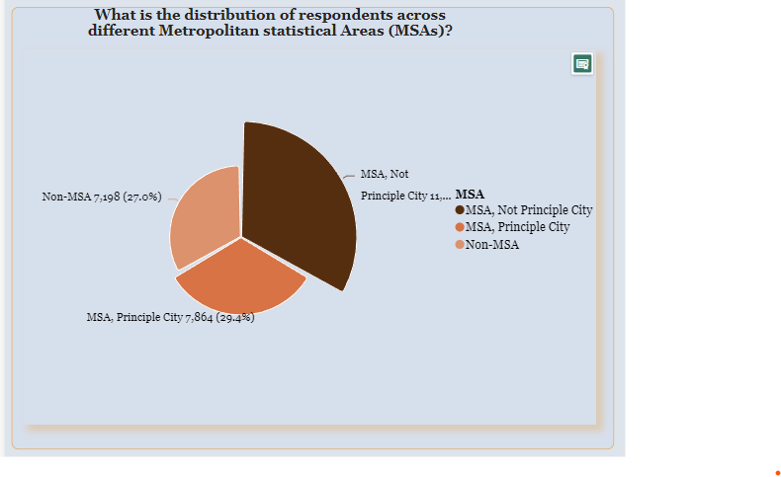

##### Fig 47. Distribution of respondents across different MSAs

MSAs often have a higher concentration of healthcare facilities, including vaccination centers. Residents in these areas may find it more convenient to access healthcare services, including vaccinations. Higher population density in MSAs may lead to increased transmission risk of infectious diseases. This heightened risk might contribute to a greater emphasis on vaccination efforts in metropolitan areas.

### 5.3.2 What is the distribution of the respondents across different MSA for each age group, considering the percentage of H1N1 vaccine uptake vs Seasonal Vaccine Uptake?

The distribution of respondents across different Metropolitan Statistical Areas (MSA) for each age group, considering the percentage of H1N1 vaccine uptake versus Seasonal Vaccine Uptake, reveals intriguing patterns in vaccination behaviors. Notably, for those who received the H1N1 Vaccine in MSA, Principle City, there is a slight increase in uptake with age, peaking at 23.9% for individuals aged 65 and above. In Non-MSA regions, the vaccine uptake is relatively consistent across age groups, with a notable increase in the 55-64 age group at 24.9%. Similarly, in MSA, Not Principle City, the vaccine uptake is consistent across age groups, with a peak at 24.5% for individuals aged 55-64.

##### Fig 48 H1N1 and Seasonal vaccine uptake rate of respondents across different MSAs for each age group

Contrastingly, the uptake of the Seasonal Vaccine demonstrates a more pronounced age-related trend. In MSA, Principle City, there is a substantial increase in uptake with age, reaching 68.1% for individuals aged 65 and above. In Non-MSA regions and MSA, Not Principle City, a similar age-related increase is observed, with the highest uptake in the 65 and above age group at 65.8% and 68%, respectively. This disparity suggests that while H1N1 vaccine uptake remains relatively stable across age groups and geographic areas, the Seasonal Vaccine is more widely embraced among older age groups, particularly in urban settings. These findings underscore the importance of tailoring vaccination strategies to address age-specific preferences and considerations, ensuring targeted and effective public health interventions.

### 5.3.3 How does the percentage of respondents with chronic medical conditions vary across different MSA?

The distribution of respondents with chronic medical conditions varies across different Metropolitan Statistical Areas (MSA), indicating potential disparities in health outcomes based on geographic settings.

##### Fig 49. Percentage of respondents with chronic medical conditions across different MSAs

In MSA, Principle City, a notable 43.18% of respondents report having chronic medical conditions, suggesting a higher prevalence in urban settings. In MSA, Not Principle City, and Non-MSA regions, the percentages are 27.87% and 28.94%, respectively, indicating a comparatively lower prevalence of chronic conditions in these areas.

This discrepancy may be influenced by factors such as access to healthcare resources, socio-economic determinants, and lifestyle differences between urban and non-urban environments. The higher prevalence in MSA, Principle City, could be attributed to factors like increased healthcare accessibility, availability of specialized medical services, or a concentration of population groups with higher health risks.

### 5.3.4 What are the income levels of the respondents in each Metropolitan Statistical Areas?

The income levels of respondents within different Metropolitan Statistical Areas (MSA) present nuanced patterns that underscore socio-economic disparities across geographic settings.

##### Fig 50. Income levels of respondents across different MSAs

In MSA, Not Principle City, a substantial 41.8% of respondents with incomes at or below $75,000 above poverty indicate a higher prevalence of lower-income individuals. Contrarily, MSA, Principle City, and Non-MSA regions exhibit relatively lower percentages at 28.5% and 29.7%, respectively. In the >$75,000 income bracket, MSA, Not Principle City, reports the highest percentage at 50.2%, suggesting a concentration of higher-income individuals in these areas.

Interestingly, MSA, Principle City, and Non-MSA regions display lower percentages at 30.2% and 19.5%, respectively. This discrepancy may be attributed to varying economic opportunities and cost of living in different geographic settings. The prevalence of respondents below the poverty line is notably higher in MSA, Not Principle City, at 34%, compared to MSA, Principle City, and Non-MSA regions.

### 5.3.5 What are the levels of knowledge and concern among the Metropolitan Statistical Areas?

##### Fig 51. Levels of Knowledge and concern of respondents across different MSAs – Part 1

The levels of H1N1 concern and knowledge among respondents across different Metropolitan Statistical Areas (MSA) reveal notable variations, providing insights into the public's awareness and apprehension about the H1N1 virus in diverse geographic settings.

##### Fig 52. Levels of Knowledge and concern of respondents across different MSAs – Part 2

In MSA, Principle City, the distribution of H1N1 concern levels indicates that 38.9% of respondents express a moderate level of concern (2 level), while in MSA, Non-Principle City, and Non-MSA regions, a slightly higher percentage of respondents, 40.8% and 38.4% respectively, fall into this category. This suggests a consistent level of moderate concern across different MSAs.

##### Fig 53. Levels of Knowledge and concern of respondents across different MSAs – Part 3

However, in MSA, Principle City, a notably lower percentage (9.7%) reports having no knowledge (0 level) about H1N1 compared to MSA, Non-Principle City (8.6%) and Non-MSA (11.9%). These findings hint at a potential association between urban settings and higher levels of knowledge regarding H1N1.

Moreover, the knowledge distribution indicates that a majority of respondents across all MSAs possess some level of knowledge (1 level) about H1N1, with MSA, Principle City, displaying the highest percentage at 54.6%. This could be attributed to increased access to educational resources and health communication initiatives in urban areas. Understanding these variations is vital for tailoring public health communication strategies and interventions to enhance awareness and address specific concerns, contributing to more effective pandemic preparedness and response efforts across diverse geographic settings.

### 5.3.6 What is the distribution of the respondents across different MSA for each employment status?

In MSA, Principle City, a notable 52% of respondents report being employed, while 6.1% are unemployed, 36% are not in the labor force, and 5.8% are not identified.

##### Fig 54. Employment Status of respondents across different MSAs

This suggests a diverse employment landscape, with a significant proportion not actively participating in the workforce, potentially influenced by factors such as education, retirement, or other non-employment pursuits.

In MSA, Not Principle City, a higher percentage (82.8%) is employed, reflecting a more workforce-centric environment, while 8.7% are unemployed, 61% are not in the labor force, and 9.3% are not identified. This highlights a higher employment concentration in non-principal city MSAs.

In Non-MSA regions, 30.1% of respondents are employed, 3% are unemployed, 25.8% are not in the labor force, and 2.9% are not identified, suggesting a different economic landscape with a lower concentration of employment opportunities.

## CONCLUSION

The comprehensive analysis of H1N1 and Seasonal flu vaccine uptake within the surveyed population provides valuable insights into vaccination behaviors, revealing discernible patterns influenced by various demographic factors. Age-related trends demonstrate a substantial preference for the Seasonal flu vaccine among older age groups, with 68.1% uptake observed in individuals aged 65 and above.

Gender and education exhibit distinct impacts on vaccine uptake, emphasizing the need for tailored communication strategies—females and college graduates show higher vaccine coverage, with 65.88% and 56.3% receiving the Seasonal flu vaccine, respectively. The correlation between household composition and dual vaccine uptake further highlights the significance of family-oriented health decisions.

Notably, households with three adults demonstrate a 47.8% likelihood of receiving both vaccines. These figures underscore the importance of targeted interventions and inclusive public health campaigns to address varying preferences and promote comprehensive vaccination coverage across diverse demographic groups. Such nuanced insights are essential for refining vaccination strategies and advancing public health goals.

## RECOMMENDATIONS

In light of the dataset's notable proportion of respondents falling into the "Not Identified" category, several recommendations emerge to enhance the quality and inclusivity of future surveys. Firstly, there is a crucial need for improved survey documentation and participant information collection methods. Clear and comprehensive instructions, coupled with assurances of confidentiality, could alleviate concerns and encourage more respondents to disclose identifiable information. Tailored communication strategies should be developed specifically for individuals who choose not to disclose personal details, emphasizing the importance of accurate data for public health planning and addressing privacy concerns.

## REFERENCES

D'Alessandro, E., Hubert, D., Launay, O., Bassinet, L., Lortholary, O., Jaffré, Y., & Sermet-Gaudelus, I. (2012, April 10). *Determinants of Refusal of A/H1N1 Pandemic Vaccination in a High Risk Population: A Qualitative Approach*. <https://scite.ai/reports/10.1371/journal.pone.0034054>

Bridget Kelly, Brian Southwell, Lauren McCormack, Carla Bann, Pia D. M. MacDonald, Alicia M. Frasier, Christine A. Bevc, Noel T. Brewer, Linda Squiers. (2021, April 12). *Predictors of willingness to get COVID-19 vaccine in the U.S.* <https://scite.ai/reports/10.1186/s12879-021-06023-9>

Lauren B. Frank. (2015, September 16). *Social Norms about a Health Issue in Work Group Networks.* <https://scite.ai/reports/10.3390/ijerph120911621>

Jeanie P. D. Guidry, Kellie E. Carlyle, Jessica Gokee LaRose, Paul B. Perrin, Mark Ryan, Marcus Messner, Jay Adams. (2018, February 05). *Framing and Visual Type: Effect on Future Zika Vaccine Uptake Intent.* <https://scite.ai/reports/10.4081/jphr.2018.1162>

Villacorta R. Value in Health, volume 16, Issue 3, A78. (2013, May) *Impact Of Doctors’ Recommendations On Seasonal And H1N1 Flu Vaccinations For Medicaid/State Children’s Health Insurance Program (Schip) Children During The 2009 H1N1 Flu Pandemic.* <https://doi.org/10.1016/j.jval.2013.03.356>

Justine Davies. Volume 139, Issue 3, P449-451. (2009, October 30). *Swine Flu Vaccines: Reaching the Finish Line.* <https://doi.org/10.1016/j.cell.2009.10.018>

Groshkopf, L. A., Shay, D. K., & Shimabukuro, T. T. (2013). *Prevention and control of seasonal influenza with vaccines: recommendations of the Advisory Committee on Immunization Practices (ACIP)—United States, 2013–2014. MMWR, 62(RR07), 1-43*.

Lu, P. J., Singleton, J. A., Euler, G. L., Williams, W. W., & Bridges, C. B. (2013). *Seasonal influenza vaccination coverage among adult populations in the United States, 2005–2011. American journal of epidemiology, 178(9), 1478-1487.*

Centers for Disease Control and Prevention. *CDC health disparities and inequalities report – United States, 2011. Health-care access and preventive health services: influenza vaccination coverage – United States, 2000 – 2010. MMWR, 60(Suppl.) (2011), pp. 38-42.*

Hebert, P. L., Frick, K. D., Kane, R. L., & McBean, A. M. (2005). *The causes of racial and ethnic differences in influenza vaccination rates among elderly Medicare beneficiaries. Health services research, 40(2), 517-538.*

Fiscella, K. (2005). *Commentary—anatomy of racial disparity in influenza vaccination. Health services research, 40(2), 539.*

O’Malley, A. S., & Forrest, C. B. (2006). *Immunization disparities in older Americans: determinants and future research needs. American Journal of Preventive Medicine, 31(2), 150-158.*

Akbulut, A. (2014). *Environmental degradation as a security threat: the challenge for developing countries.* International Journal of Human Sciences / Uluslararası İnsan Bilimleri Dergisi, 11(1), 1227-1237. <https://doi.org/10.14687/ijhs.v11i1.2894>

Schutter, B. D., Brown, J., & Abeele, V. V. (2014). *The domestication of digital games in the lives of older adults.* New Media &Amp; Society, 17(7), 1170-1186. <https://doi.org/10.1177/1461444814522945>

Yıldırım, H. and Işık, K. (2020). *Psychometric evaluation of the hospitalisation‐related stressors questionnaire for elderly patients*. Psychogeriatrics, 21(2), 166-174. <https://doi.org/10.1111/psyg.12651>

Schutter, B. D., Brown, J., & Abeele, V. V. (2014). *The domestication of digital games in the lives of older adults.* New Media &Amp; Society, 17(7), 1170-1186. <https://doi.org/10.1177/1461444814522945>

Zou, W., Hong, G., Yamazaki, Y., Takase, K., Ogawa, T., Washio, J., … & Sasaki, K. (2020). *Use of cellulose nanofibers as a denture immersing solution*. Dental Materials Journal, 39(1), 80-88. <https://doi.org/10.4012/dmj.2018-388>

## APPENDIX

### Data Pre-Processing

To derive dependable insights from data, it is imperative to undergo the process of data transformation and preparation, involving the structuring, combination, and organization of data for subsequent utilization in analytics, business intelligence, and visualizations. This meticulous process not only ensures the preparedness of data for analysis but also contributes to the attainment of consistent and accurate results.

In the specific context of PowerBI analysis, a series of methodical steps were executed, encompassing:

* the identification of data,
* loading it into PowerBI,
* subsequent processing,
* modeling, and
* application of necessary transformations.

The ensuing stages involved the creation of visualizations, designs, and branding for the data. Crucial terms integral to this academic discourse include "power query," a tool facilitating data connectivity and preparation by transforming and linking data, encompassing actions such as converting data types, eliminating blanks, columns, and rows, and creating calculated and conditional columns. Additionally,

Data Analysis Expression (DAX) emerges as a central concept, constituting operators, functions, and constants that formulate expressions or formulas, thereby calculating and retrieving values to generate novel insights from existing data.

The dataset consists of one dataset in CSV format:

##### Fig 55. Dataset in Excel

The very first step is to import data into PowerBI using by clicking “Get Data”

##### Fig 56. Get Data into PowerBI

Create dimensions.

##### Fig 57. Create Dimensions

### Cleaning Process

*Main Dataset*

##### Fig 58. Illustration of cleaning process in PowerBI of the main dataset

*Behavioral Information*

##### Fig 59. Illustration of cleaning process in PowerBI of ‘Behavioral Information’ dimension

*Doctor’s Recommendation*

##### Fig 60. Illustration of cleaning process in PowerBI of ‘Doctor’s Recommendation’ dimension

*Knowledge/Concern*

##### Fig 61. Illustration of cleaning process in PowerBI of ‘Knowledge/Concern’ dimension

*Chronic Level*

##### Fig 62. Illustration of cleaning process in PowerBI of ‘Chronic Level’ dimension

*Opinion*

##### Fig 63. Illustration of cleaning process in PowerBI of ‘Opinion’ dimension

*Received Vaccine*

##### Fig 64. Illustration of cleaning process in PowerBI of ‘Received Vaccine’ dimension

*Household Persons*

##### Fig 65. Illustration of cleaning process in PowerBI of ‘Household Persons’ dimension

*Census MSA*

##### Fig 66. Illustration of cleaning process in PowerBI of ‘Census MSA’ dimension

*Employment Status*

##### Fig 67. Illustration of cleaning process in PowerBI of ‘Employment Status’ dimension

*Health Worker*

##### Fig 68. Illustration of cleaning process in PowerBI of ‘Health Worker’ dimension

*Health Insurance*

##### Fig 69. Illustration of cleaning process in PowerBI of ‘Health Insurance’ dimension

*Personal Information*

##### Fig 70. Illustration of cleaning process in PowerBI of ‘Personal Information’ dimension

*Income Level*

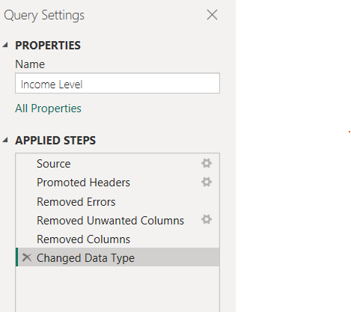

##### Fig 71. Illustration of cleaning process in PowerBI of ‘Income Level’ dimension

*Rent or Own*

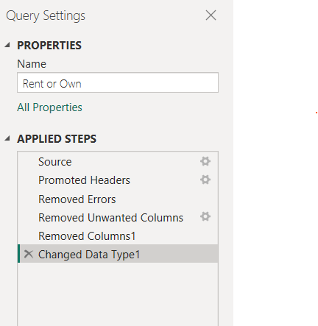

##### Fig 72. Illustration of cleaning process in PowerBI of ‘Rent or Own’ dimension

*Has a child under 6 months*

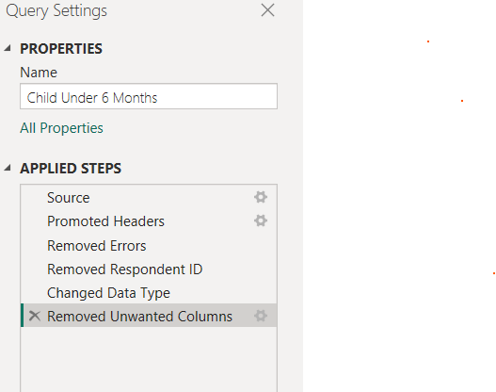

##### Fig 73. Illustration of cleaning process in PowerBI of ‘Child Under 6 months’ dimension

### DAX and M Language

*Main Dataset*

##### Fig 74. M Language illustration of cleaning process in PowerBI of the main dataset

*Dimension 1 - Behavioral Information*

##### Fig 75. M Language illustration of cleaning process in PowerBI of the ‘Behavioral Information’ dimension

*Dimension 2 – Doctor’s Recommendation*

##### Fig 76. M Language illustration of cleaning process in PowerBI of the ‘Doctor’s Recommendation’ dimension

*Dimension 3 – Knowledge/Concern*

##### Fig 77. M Language illustration of cleaning process in PowerBI of the ‘Knowledge/Concern’ dimension

*Dimension 4 – Chronic Level*

##### Fig 78. M Language illustration of cleaning process in PowerBI of the ‘Chronic Level’ dimension

*Dimension 5 – Opinion*

##### Fig 79. M Language illustration of cleaning process in PowerBI of the ‘Opinion’ dimension

*Dimension 6 – Received Vaccine*

##### Fig 80. M Language illustration of cleaning process in PowerBI of the ‘Received Vaccine’ dimension

*Dimension 7 – Household Persons*

##### Fig 81. M Language illustration of cleaning process in PowerBI of the ‘Household Persons’ dimension

*Dimension 7 – Census MSA*

##### Fig 82. M Language illustration of cleaning process in PowerBI of the ‘Census MSA’ dimension

*Dimension 7 – Employment Status*

##### Fig 83. M Language illustration of cleaning process in PowerBI of the ‘Employment Status’ dimension

*Dimension 7 – Health Worker*

##### Fig 84. M Language illustration of cleaning process in PowerBI of the ‘Health Worker’ dimension

*Dimension 7 – Health Insurance*

##### Fig 85. M Language illustration of cleaning process in PowerBI of the ‘Health Insurance’ dimension

*Dimension 7 – Personal Information*

##### Fig 86. M Language illustration of cleaning process in PowerBI of the ‘Personal Information’ dimension

*Dimension 7 – Income Level*

##### Fig 87. M Language illustration of cleaning process in PowerBI of the ‘Income Level’ dimension

*Dimension 7 – Rent or Own*

##### Fig 88. M Language illustration of cleaning process in PowerBI of the ‘Rent or Own’ dimension

*Dimension 7 – Child Under 6 Months*

##### Fig 89. M Language illustration of cleaning process in PowerBI of the ‘Child Under 6 months’ dimension

### Dashboard

***Overview***

##### Fig 90. Dashboard

#### Vaccination Rates

##### Fig 91. Dashboard – Vaccination Rates

*Overall Vaccination Rate*

This visual represents the percentage of respondents who have been vaccinated against either H1N1 or the seasonal flu or both. It's a valuable metric for assessing the level of immunization and understanding the reach of vaccination efforts.

##### Fig 92. Dashboard – Overall Vaccination Rate DAX formula

*H1N1 Vaccination Rate*

This represents the percentage of respondents who received the H1N1 influenza vaccine.

##### Fig 93. Dashboard – H1N1 Vaccination Rate DAX formula

*Seasonal Vaccination Rate*

This is a measure used to quantify the number of respondents who have been vaccinated against the seasonal flu.

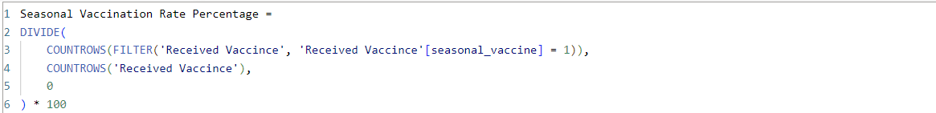

##### Fig 94. Dashboard – Seasonal Vaccination Rate DAX formula

#### Public Concern and Knowledge

##### Fig 95. Dashboard – Public Concern and Knowledge

Analyzing these columns can provide insights into how informed and concerned the public is about the H1N1 virus

*Average Knowledge about H1N1*



##### Fig 96. Dashboard – Average Knowledge about H1N1 DAX formula

*Average C0ncern about H1N1*

##### Fig 97. Dashboard – Average Concern about H1N1 DAX formula

#### Doctor’s Recommendations

##### Fig 98. Dashboard – Doctor’s Recommendations

This information provides insights into the influence of healthcare professionals on individuals' vaccination decisions.

*Doctor’s Recommendation Rate for Seasonal Vaccine*

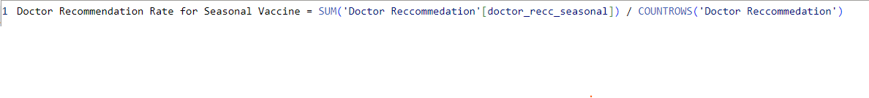

##### Fig 99. Dashboard Doctor’s Recommendations for Seasonal Vaccine DAX formula

*Doctor’s Recommendation Rate for H1N1 Vaccine*

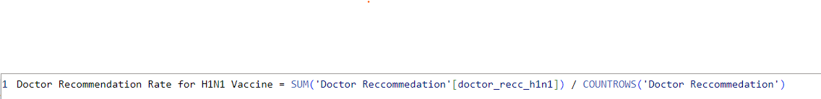

##### Fig 100. Dashboard Doctor’s Recommendations for H1N1 Vaccine DAX formula

**Number of Adults and children in a household**

##### Fig 101. Dashboard – Household Persons

*Average No. of Adults in a Household*

##### Fig 102. Dashboard Average No. of Adults in a Household DAX formula

*Average No. of Children in a Household*

##### Fig 103. Dashboard Average No. of Children in a Household DAX formula

#### Number of Health Workers and respondents with Insurance

##### Fig 104. Dashboard – Health Workers and Insurance

*Health Workers*

##### Fig 105. Dashboard Total Number of Health Workers DAX formula

*Percentage of respondents with health insurance*

##### Fig 106. Dashboard Percentage Number of respondents with Health Insurance DAX formula

#### Rent payers and Home owners

##### Fig 107. Dashboard – Rent Payers and Home owners

*Percentage of respondents who are rent payers.*

##### Fig 108. Dashboard Percentage Number of Rent payers DAX formula

*Percentage of respondents who are home owners.*

##### Fig 109. Dashboard Percentage Number of Home owners DAX formula

#### Age Distribution of respondents

##### Fig 110. Dashboard – Age Distribution of the respondents

This visual did not utilize the use of a DAX, instead it used the ‘Personal Information’ dimension to view the results

##### Fig 111. Dashboard Personal Information Table/Dimension

#### Employment Status and Income Level

##### Fig 112. Dashboard – Employment Status and Income Level

*Employment Status*

This visual did not utilize the use of a DAX, instead it used the ‘Employment Status’ dimension to view the results

##### Fig 113. Dashboard Employment Status Table/Dimension

*Income Levels*

This visual did not utilize the use of a DAX, instead it used the ‘Income Level’ dimension to view the results.

##### Fig 114. Dashboard Income Level Table/Dimension

#### Children Under 6 Months

This card is used to visualize what percentage of respondents have children under the age of 6 months.

##### Fig 115. Dashboard – Respondents with children under 6 months

##### Fig 116. Dashboard Percentage of Respondents with children under 6 months DAX formula

#### Number of people who believe in the Effectiveness of H1N1 Vaccine and Seasonal Vaccine

##### Fig 117. Dashboard – Number of people who believe in the Effectiveness of H1N1 and Seasonal Vaccine

This information helps to provide insights into public perceptions of vaccine effectiveness.

*H1N1 Vaccine Effectiveness*

This insight used the Opinion dimension to bring the data to life and derive insights from it

##### Fig 118. Dashboard Opinion Table/Dimension

This insight used the Opinion dimension to bring the data to life and derive insights from it

##### Fig 119. Dashboard Opinion Table/Dimension

## SELF ASSESSMENT

Use the table below to self-assess your work. This will help reflect on your work. You must keep this table in your report.

|  |  |  |
| --- | --- | --- |
| **Report Section** | **Description** | **Grade your work from 0 to 100** |
| Report structure | The report is well-written and it contains all the relevant sections | 90 |
| Data Pre-processing and Data Modelling | Many pre-processing steps have been applied. The data model is well-structured | 85 |
| DAX and M Language | Both DAX and M Language have been **extensively** used in the report | 85 |
| Dashboard Design | The dashboard contains a  variety of charts, including  advanced ones not  covered in the module. | 90 |
| **Average** |  | **Add below the average**  **of the four cells above:**  **87.5** |